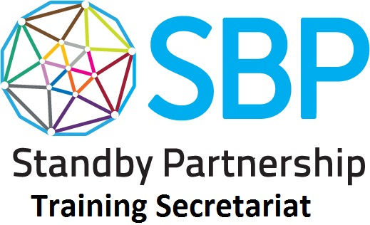PEER SKILLS CHECKLIST

Print and handout the different sections of this checklist based on the activity. Explain to participants that this form is to be used to visually assess if they think their colleagues were able to apply certain SBP skills, as outlined in the SBP competency framework. Remind them to give honest, helpful feedback that supports and encourages growth. After they have assessed each team member they can cut out each box and give the feedback to them individually.

EXERCISE ONE: WORKING AS A TEAM PART ONE

Participant Name: | I totally agree | I agree | I somewhat disagree | I disagree | Ways to improve

My teammember was able to:
Build consensus for task purpose with team members
Adapt interpersonal style to suit different people and situations

Participant Name: | I totally agree | I agree | I somewhat disagree | I disagree | Ways to improve

My teammember was able to:
Build consensus for task purpose with team members
Adapt interpersonal style to suit different people and situations

Participant Name: | I totally agree | I agree | I somewhat disagree | I disagree | Ways to improve

My teammember was able to:
Build consensus for task purpose with team members
Adapt interpersonal style to suit different people and situations

Participant Name: | I totally agree | I agree | I somewhat disagree | I disagree | Ways to improve

My teammember was able to:
Build consensus for task purpose with team members
Adapt interpersonal style to suit different people and situations

Participant Name: | I totally agree | I agree | I somewhat disagree | I disagree | Ways to improve

My teammember was able to:
Build consensus for task purpose with team members
Adapt interpersonal style to suit different people and situations

Participant Name: | I totally agree | I agree | I somewhat disagree | I disagree | Ways to improve

My teammember was able to:
Build consensus for task purpose with team members
Adapt interpersonal style to suit different people and situations

EXERCISE THREE: IDENTIFYING OBJECTIVES, ACTIVITIES AND RESOURCES
Please fill this form out as a team after each presentation. Remember to give honest, helpful feedback that supports and encourages growth.

NAME OF GROUP_____________________________________________________________________________________________________________________

 | I totally agree | I agree | I somewhat disagree | I disagree | Ways to improve

The group was able to:
Integrate gender, age and diversity considerations into their humanitarian response plan?
Identify clients' needs and match them to appropriate solutions ?
Set clear goals, objectives, and activities with resources?
Plan, prioritize and monitor tasks to achieve realistic deadlines?
Analyse information to identify its different elements, patterns and relationships?
Identify methods to address problems and produce workable solutions?

Other comments:

