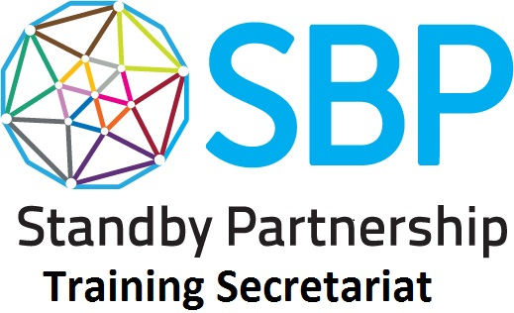
COMMON INDUCTION PACKAGE: SUGGESTED 5-DAY AGENDA

Time \ Day | Day 1 | Day 2 | Day 3 | Day 4 | Day 5
60-100 minutes | Welcome and Introduction | Domain #2_3 Respect for diversity & Maintaining a service oriented approach (100min) | Domain #8 Adhering to humanitarian principles and codes of conduct Module 2 Working for the UN (90min) | Tabletop Exercise Task 2 (90min) | Domain #1 Coping with pressure and adapting to change (90min)
Morning Tea / Coffee Break
60-140 minutes | Domain #8 Adhering to humanitarian principles and codes of conduct Module 1 Terms of Service (90min) | Domain #4 Module 3 Humanitarian Landscape (140min) | Domain #8 Adhering to humanitarian principles and codes of conduct Module 3 Code of Conduct (60 min) | Tabletop Exercise Task 3 (90min) | Wrap up and closing
Lunch
100-120 minutes | Domain #4 Understanding humanitarian systems and promoting humanitarian principles: Module 1 Legal Frameworks and Humanitarian Principles (100min) | Domain #5 Personal Commitment to Achieving Results (45min) | Domain #7 Planning and Organising (60min) | Tabletop Exercise Task 4 (90min)
 |  | Domain #6 Module 1 Communication Skills: Active Listening & Negotiation (60 min) | Domain #10 Demonstrating Critical Judgement (45min)
Afternoon Tea / Coffee Break
60-100 minutes | Domain #4 Module 2 Guidelines & Standards (70min) | Domain #6 Module 2 Communication Skills: Meeting Management (60min) | Domain #11 Module Working effectively in teams (90min) | Tabletop Exercise Task 5 (60min)
 |  | Domain #4 Module 4 Platforms & Tools (45min) | Tabletop Exercise Introduction & Task 1 (45min) | Tabletop Exercise Task 6 & Debrief (30min)

